- Write a Python program to draw a line with suitable label in the x axis, y axis and a title.

import matplotlib.pyplot as plt
x = [0, 1, 2, 3, 4, 5]
y = [0, 1, 4, 9, 16, 25]
plt.plot(x, y, marker='o', color='y')
plt.xlabel('X Axis')
plt.ylabel('Y Axis')
plt.title('Simple Line Plot')
plt.grid()
plt.show()

output:

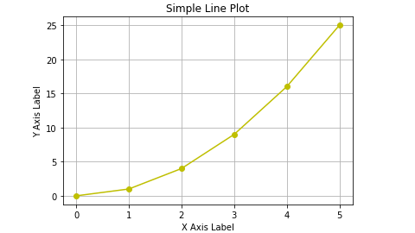

- Write a Python program to draw a line using given axis values taken from a text file, with suitable label in the x axis, y axis and a title.
test.txt
1 2
2 4
3 1

import matplotlib.pyplot as plt
x = []
y = []
with open('test.txt', 'r', encoding='utf-8-sig') as file:
for line in file:
values = line.split()
x.append(int(values[0]))
y.append(int(values[1]))

plt.plot(x, y, marker='o', color='b')
plt.xlabel("X-Axis")
plt.ylabel("Y-Axis")
plt.title("Line Graph from Text File")
plt.grid()
plt.show()

output:
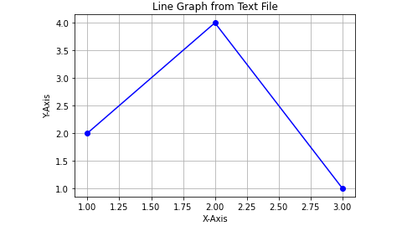

- Write a Python program to draw line charts of the financial data of Alphabet Inc. between October 3, 2016 to October 7, 2016.
Date,Open,High,Low,Close
10-03-16,774.25,776.065002,769.5,772.559998
10-04-16,776.030029,778.710022,772.890015,776.429993
10-05-16,779.309998,782.070007,775.650024,776.469971
10-06-16,779,780.47998,775.539978,776.859985
10-07-16,779.659973,779.659973,770.75,775.080017

import matplotlib.pyplot as plt
import pandas as pd
from io import StringIO
data = """Date,Open,High,Low,Close
10-03-16,774.25,776.065002,769.5,772.559998
10-04-16,776.030029,778.710022,772.890015,776.429993
10-05-16,779.309998,782.070007,775.650024,776.469971
10-06-16,779,780.47998,775.539978,776.859985
10-07-16,779.659973,779.659973,770.75,775.080017
"""
df = pd.read_csv(StringIO(data), sep=',', parse_dates=['Date'], dayfirst=True)
df.set_index('Date', inplace=True)
plt.figure(figsize=(10, 6))
plt.plot(df.index, df['Open'], marker='o', label='Open Price', color='blue')
plt.plot(df.index, df['High'], marker='o', label='High Price', color='green')
plt.plot(df.index, df['Low'], marker='o', label='Low Price', color='red')
plt.plot(df.index, df['Close'], marker='o', label='Close Price', color='orange')
plt.xlabel('Date')
plt.ylabel('Price (USD)')
plt.title('Financial Data of Alphabet Inc. (Oct 3, 2016 - Oct 7, 2016)')
plt.xticks(rotation=45)
plt.legend()
plt.grid()
plt.tight_layout()
plt.show()

output:

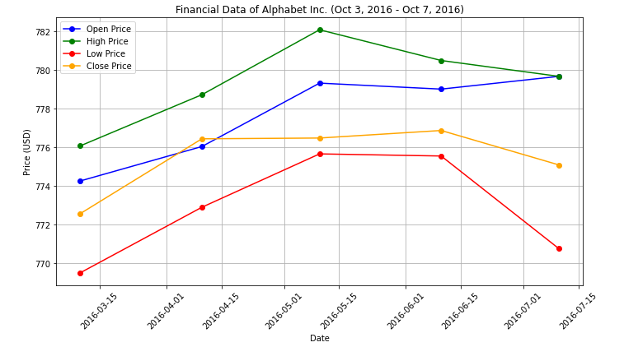

- Write a Python program to plot two or more lines on same plot with suitable legends of each line.

import matplotlib.pyplot as plt
x = [0, 1, 2, 3, 4, 5]

line1_y = [0, 1, 4, 9, 16, 25]
line1_label = 'Line 1'
line1_color = 'blue'

line2_y = [0, 2, 1, 3, 2, 4]
line2_label = 'Line 2'
line2_color = 'red'

line3_y = [0, 1, 2, 1, 2, 3]
line3_label = 'Line 3'
line3_color = 'green'
fig, ax = plt.subplots(figsize=(8, 6))
ax.plot(x, line1_y, marker='o', color=line1_color, label=line1_label)
ax.plot(x, line2_y, marker='o', color=line2_color, label=line2_label)
ax.plot(x, line3_y, marker='o', color=line3_color, label=line3_label)
ax.set_xlabel('X Axis Label')
ax.set_ylabel('Y Axis Label')
ax.set_title('Multiple Lines with Legends')
ax.legend()
ax.grid()
plt.tight_layout()
plt.show()

output:
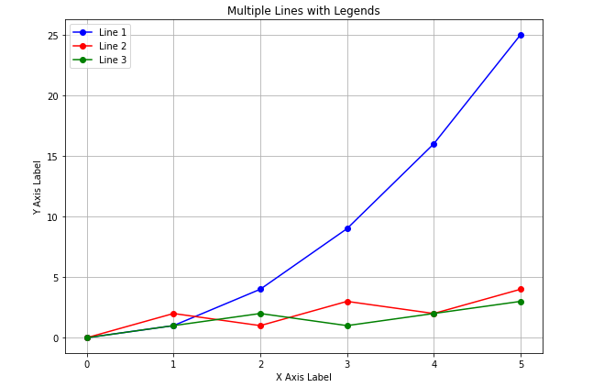
- Write a Pandas program to create and display a one-dimensional array-like object(series) containing an array of data using Pandas module. Accept the values for the series from the keyboard. Display the content.

import pandas as pd
def create_series_from_input():
user_input = input("Enter values for the series separated by commas: ")
data_list = [value.strip() for value in user_input.split(',')]
series = pd.Series(data_list)
print("\nThe created Pandas Series is:")
print(series)

if __name__ == "__main__":
create_series_from_input()

output:
Enter values for the series separated by commas: 10,20,30,40,50

The created Pandas Series is:
0 10
1 20
2 30
3 40
4 50
dtype: object

- Write a Pandas program to convert a Panda module Series to Python list and it's type. Display the list. Hint: dataframe has tolist() function

import pandas as pd

def series_to_list():
data = [10, 20, 30, 40, 50]
series = pd.Series(data)
python_list = series.tolist()
print("The Pandas Series:")
print(series)
print("\nConverted Python List:")
print(python_list)
print("\nType of the list:", type(python_list))

if __name__ == "__main__":
series_to_list()

output:
The Pandas Series:
0 10
1 20
2 30
3 40
4 50
dtype: int64

Converted Python List:
[10, 20, 30, 40, 50]

Type of the list: <class 'list'>

7 Write a Pandas program to add, subtract, multiple and divide two Pandas Series. Accept data through the keyboard. Display the resultant series. Hint: Use +, -, *, / operator.
Sample Series: [2, 4, 6, 8, 10], [1, 3, 5, 7, 9].

import pandas as pd

def perform_operations_on_series():
first_series_input = input("Enter the first series of numbers separated by commas: ")
first_series_data = [float(value.strip()) for value in first_series_input.split(',')]
second_series_input = input("Enter the second series of numbers separated by commas: ")
second_series_data = [float(value.strip()) for value in second_series_input.split(',')]

series1 = pd.Series(first_series_data)
series2 = pd.Series(second_series_data)

addition = series1 + series2
subtraction = series1 - series2
multiplication = series1 * series2
division = series1 / series2

print("\nFirst Series:")
print(series1)
print("\nSecond Series:")
print(series2)
print("\nAddition Result:")
print(addition)
print("\nSubtraction Result:")
print(subtraction)
print("\nMultiplication Result:")
print(multiplication)
print("\nDivision Result:")
print(division)
if __name__ == "__main__":
perform_operations_on_series()

output:
Enter the first series of numbers separated by commas: 10,20,30,40,50
Enter the second series of numbers separated by commas: 50,60,70,70,80

First Series:
0 10.0
1 20.0
2 30.0
3 40.0
4 50.0
dtype: float64

Second Series:
0 50.0
1 60.0
2 70.0
3 70.0
4 80.0
dtype: float64

Addition Result:
0 60.0
1 80.0
2 100.0
3 110.0
4 130.0
dtype: float64

Subtraction Result:
0 -40.0
1 -40.0
2 -40.0
3 -30.0
4 -30.0
dtype: float64

Multiplication Result:
0 500.0
1 1200.0
2 2100.0
3 2800.0
4 4000.0
dtype: float64

Division Result:
0 0.200000
1 0.333333
2 0.428571
3 0.571429
4 0.625000
dtype: float64

8 Write a Pandas program to compare the elements of the two Pandas Series for which data has been accepted through the keyboard. . Hint: Use ==, >, < operators
Sample Series: [2, 4, 6, 8, 10], [1, 3, 5, 7, 10]

import pandas as pd

def compare_series():

first_series_input = input("Enter the first series of numbers separated by commas: ")
first_series_data = [float(value.strip()) for value in first_series_input.split(',')]

second_series_input = input("Enter the second series of numbers separated by commas: ")
second_series_data = [float(value.strip()) for value in second_series_input.split(',')]

series1 = pd.Series(first_series_data)
series2 = pd.Series(second_series_data)

equality = series1 == series2
greater_than = series1 > series2
less_than = series1 < series2

print("\nFirst Series:")
print(series1)
print("\nSecond Series:")
print(series2)
print("\nEquality Comparison (series1 == series2):")
print(equality)
print("\nGreater Than Comparison (series1 > series2):")
print(greater_than)
print("\nLess Than Comparison (series1 < series2):")
print(less_than)

if __name__ == "__main__":
compare_series()

output:

Enter the first series of numbers separated by commas: 10,20,30,40
Enter the second series of numbers separated by commas: 50,60,70,80

First Series:
0 10.0
1 20.0
2 30.0
3 40.0
dtype: float64

Second Series:
0 50.0
1 60.0
2 70.0
3 80.0
dtype: float64

Equality Comparison (series1 == series2):
0 False
1 False
2 False
3 False
dtype: bool

Greater Than Comparison (series1 > series2):
0 False
1 False
2 False
3 False
dtype: bool

Less Than Comparison (series1 < series2):
0 True
1 True
2 True
3 True
dtype: bool
[ ]:
​
9 Write a Pandas program to convert a dictionary(with elements empno,ename and basic) for which you accept values through the keyboard, to a Pandas series.
Original dictionary:
eg: {'empno': 101, 'ename': ‘ann’, 'basic': 3000, }

import pandas as pd

def create_employee_series():
empno = int(input("Enter Employee Number (empno): "))
ename = input("Enter Employee Name (ename): ")
basic = float(input("Enter Basic Salary (basic): "))
employee_dict = {
'empno': empno,
'ename': ename,
'basic': basic
}
employee_series = pd.Series(employee_dict)
return employee_series

if __name__ == "__main__":
employee_series = create_employee_series()
print("\nEmployee Series:")
print(employee_series)

output:
Enter Employee Number (empno): 101
Enter Employee Name (ename): aishwarya
Enter Basic Salary (basic): 25000

Employee Series:
empno 101
ename aishwarya
basic 25000.0
dtype: object

10 Write a Pandas program to accept 5 elements into a numpy array and convert the NumPy array to a Pandas series.

import numpy as np
import pandas as pd

def numpy_array_to_series():
elements = []
for i in range(5):
element = input(f"Enter element {i + 1}: ")
elements.append(element)
numpy_array = np.array(elements)
pandas_series = pd.Series(numpy_array)
return pandas_series

if __name__ == "__main__":
pandas_series = numpy_array_to_series()
print("\nPandas Series:")
print(pandas_series)
[ ]:

output:
Enter element 1: 100
Enter element 2: 45
Enter element 3: 678
Enter element 4: 45
Enter element 5: 23

Pandas Series:
0 100
1 45
2 678
3 45
4 23
dtype: object

